

**SIMATS SCHOOL OF ENGINEERING**

**SAVEETHA INSTITUTE OF MEDICAL AND TECHNICAL SCIENCES**

**CHENNAI-602105**

**CREATE A WEBSITE FOR AN ONLINE SHOPPING SYSTEM FOR FASHION WEAR**

**A CAPSTONE PROJECT REPORT**

*Submitted in the partial fulfillment for the award of the degree of*

**BACHELOR OF ENGINEERING**

**IN**

**Computer Science and Engineering**

**Submitted by**

**P.V.L SANDHYA MADHURI (192211093)**

**N. KAMALANI (192210354)**

**Under the Supervision of**

**DR.S.K. SARAVANAN**

**JULY 2024**

**DECLARATION**

We, **P.V.L SANDHYA MADHURI, Kamalani Nagella** students of **Bachelor of Engineering in CSE**, Department of Computer Science and Engineering, Saveetha Institute of Medical and Technical Sciences, Saveetha University, Chennai, hereby declare that the work presented in this Capstone Project Work entitled **A WEBSITE FOR AN ONLINE SHOPPING SYSTEM FOR FASHION WEAR.** is the outcome of our own bonafide work and is correct to the best of our knowledge and this work has been undertaken taking care of Engineering Ethics.

**P.V.L SANDHYA MADHURI (192211093)**

**N. KAMALANI (192210354)**

Date:

Place:

**CERTIFICATE**

This is to certify that the project entitled **“A WEBSITE FOR AN ONLINE SHOPPING SYSTEM FOR FASHION WEAR”** submitted by **Sandhya Madhuri, kamalani Nagella** has been carried out under my supervision. The project has been submitted as per the requirements in the current semester of B.E. Computer Science Engineering.

**DR.S.K. SARAVANAN**

Teacher-in-charge

**Table of Contents**

|  |  |  |
| --- | --- | --- |
| **S.NO** | **TOPICS** | **Page No** |
| **1** | **Abstract** | **5** |
| **2** | **Introduction** | **5** |
| **3** | **Project Description** | **5** |
| **4** | **Problem Description** | **6** |
| **5** | **Tool Description** | **6** |
| **6** | **Operations** | **7** |
| **7** | **Module Description** | **8** |
| **8** | **Implementation** | **9-15** |
| **9** | **Result** | **15** |
| **10** | **Conclusion** | **16** |
| **11** | **Future Enhancements** | **16** |
|  | **Screenshots** | **17-19** |
|  | **References** | **19** |

**1.ABSTRACT**  
  
The user-focused web application "Our Fashion Store" is made for effective administration and discovery of clothing. The platform, which was created with Visual Studio for front-end programming and XAMPP and PHP for back-end functions, provides consumers with an easy-to-use interface for perusing, buying, and reviewing clothing. Users have the option to safely register, log in to control their orders and profiles, and use the powerful search features to look up products by name or category. Users may effortlessly examine full product information, such as sizes, colours, and materials, thanks to the application's support for comprehensive product administration.

"Our Fashion Store" employs a user-friendly interface to enable smooth interaction while emphasizing user involvement and intuitive navigation. To improve the purchasing experience, products are accompanied by thorough descriptions and photographs, appealing to both casual and fashion-forward customers. In order to create a dynamic community of fashion enthusiasts and encourage innovation and knowledge exchange in the field of fashion administration.

**2.INTRODUCTION**

In a time when e-commerce is booming and people are becoming more and more interested in purchasing online, efficient PMS systems are becoming essential resources for professional merchants as well as individual consumers. Conventional product organization techniques, such physical catalogues or disjointed digital data, frequently fall short in offering efficient sharing, easy retrieval, and systematic storage. Acknowledging these obstacles, the web application "Our Fashion Store" presents a comprehensive solution intended to improve accessibility, encourage creative purchasing, and streamline product administration

"Our Fashion Store" provides a user-centric platform by utilizing contemporary web technologies to tackle the inherent problems of product administration. The program, which was created with Visual Studio for front-end design and the powerful XAMPP stack (Apache, MySQL, PHP) for back-end operations, attempts to close the gap between conventional product storage techniques and modern digital requirements. The goal of "Our Fashion Store" is to provide consumers with a seamless and pleasurable purchasing experience by incorporating administrative controls, straightforward product creation and editing functionality, comprehensive search capabilities, and user identification.

This project seeks to encourage fashion exploration and community interaction in addition to streamlining the organization of products. "Our Fashion Store" seeks to transform the way people organize, find, and share their favourite fashion goods by giving consumers a concentrated location for their picks, augmented with interactive elements and adaptable design. This introduction lays the groundwork for examining the processes, features, and results of the "Our Fashion Store" web application, emphasizing how it might change product management procedures in the digital era.

**3. PROJECT DESCRIPTION**

"Our Fashion Store" is a comprehensive web application developed to streamline fashion wear management. The application includes:

**Proposed Method**

**Frontend Development**: Utilizing Visual Studio for designing responsive and intuitive user interfaces.

**Backend Development:** Using XAMPP stack (Apache, MySQL, PHP) to handle server-side scripting, database management via phpMyAdmin, and ensuring secure data storage and retrieval.

**4. PROBLEM DESCRIPTION**

**Existing System**

The current manual payment methods for online purchases are riddled with inefficiencies that make it difficult for customers to have a seamless shopping experience. Due to the manual entry of payment details, which slows down transaction completion and increases the likelihood of abandoned carts, lengthy processing delays during checkout are a regular issue. Retailers risk losing sales as a result of this, in addition to increasing consumer displeasure a  
  
Furthermore, human mistake can result in inaccurate charges, disputes, and possible revenue losses for online retailers when using manual payment entry methods. Keeping track of payments and efficiently managing transaction records are made more challenging by the absence of an efficient record-keeping system. Furthermore, it can be inconvenient to use traditional systems' restricted payment alternatives.

These difficulties draw attention to the need for a more effective, dependable, and user-friendly solution that can improve the payment process for online purchases. These issues can be resolved by implementing an automated online payment system, which will guarantee quicker processing times, lower error rates, and offer a more practical and safe payment method.

**Proposed System**

The proposed Online Shopping System is designed to enhance efficiency and user convenience by enabling secure online purchases and order management. Users can register, browse products, make payments, and access detailed reports of their transactions, with total amounts automatically calculated based on selected items. The system features user registration and authentication, ensuring secure access and data protection. It includes a responsive design for compatibility across devices and utilizes a robust architecture with a MySQL database, PHP for server-side processing, and HTML, CSS, and JavaScript for a user-friendly interface. This centralized platform will streamline the shopping experience, reduce time spent on transactions, and offer a secure, modern solution for online retail.

**5. TOOL DESCRIPTION**

#### Hardware and Software Tools

To develop and deploy the online tollgate web application, the following hardware and software tools were utilized:

**Hardware Specifications**

* **Laptop Model**: LENOVO LOQ
* **Graphics Card**: NVIDIA GeForce RTX 3050, 6GB
* **Storage**: 500GB SSD
* **RAM**: 16GB
* **Processor**: 12th Gen Intel(R) Core (TM) i5-12450H 2.00 GHz

**Software Tools**

* **Visual Studio Code**: An integrated development environment (IDE) used for writing and debugging code. Its extensions and integrated terminal enhanced the coding experience.
* **XAMPP**: A free and open-source cross-platform web server solution stack package developed by Apache Friends. It provided the necessary Apache, MySQL, PHP, and Perl support for local development and testing.
* **phpMyAdmin**: A free software tool written in PHP, intended to handle the administration of MySQL over the web. phpMyAdmin was used for database management, allowing for easy handling of the MySQL database used in the application.
* **Google Chrome**: The primary web browser used for testing and debugging the web application. Developer tools in Chrome facilitated real-time inspection and modification of the front-end code.

The combination of powerful hardware and a robust set of development tools provided a conducive environment for the efficient development, testing, and deployment of the recipe management web application.

1. **OPERATIONS**

The Online Shopping System provides various operations for users to manage their shopping experience effectively and ensure a smooth user journey. Below are the detailed operations based on the provided code and functionalities of the application:

**User Registration and Authentication**

* **User Registration:** New users can create an account by providing necessary information such as name, email, and password.
* **User Login:** Registered users can log in securely using their email and password.
* **Password Management:** Users can reset or change their passwords to maintain account security.

**Product Management**

* **Browse Products:** Users can browse a wide range of products categorized for easy navigation.
* **Search Functionality:** Users can search for specific products using keywords.
* **Product Details:** Users can view detailed information about each product, including descriptions, prices, and reviews.

**Shopping Cart Operations**

* **Add to Cart:** Users can add products to their shopping cart for future purchase.
* **View Cart:** Users can view the contents of their shopping cart, including product details and total cost.
* **Update Cart:** Users can update the quantity of products in their cart or remove items.
* **Checkout:** Users can proceed to checkout, where they can review their order and make payments.

**Payment Processing**

* **Multiple Payment Options:** The system supports various payment methods such as credit/debit cards, PayPal, and other online payment gateways.
* **Secure Payment Gateway:** All transactions are processed through a secure payment gateway to ensure data protection.

**Order Management**

* **Order History:** Users can view their past orders, including details of products purchased, dates, and total amounts.
* **Order Tracking:** Users can track the status of their current orders.
* **Invoice Generation:** Users can download invoices for their purchases.

#### Modules and Functionalities

To develop the Online Shopping System, we will divide the project into distinct modules, each responsible for specific functionalities. By creating individual functions for every operation and unifying them, we can ensure modularity, maintainability, and scalability

**7.1 Interaction Module (User)**

**Function: Home Page**

* **Description:** Provides users with an introductory overview of the online shopping platform.

**Function: About Us Page**

* **Description:** Offers detailed information about the online shopping platform and its mission.
* **Functionalities:**
  + Display information about the platform’s purpose, benefits, and values.
  + Include background details and the company’s objectives.

**Function: Contact Form**

* **Description:** Allows users to send inquiries or feedback through a contact form.
* **Functionalities:**
  + Input fields for name, email, subject, and message.
  + Validate and submit the contact form to the server for processing.

**Function: Search Products**

* **Description:** Enables users to search for specific products based on criteria such as product name, category, or price range.
* **Functionalities:**
  + Filter and display product listings based on search input.
  + Dynamically update search results as the user types or selects criteria.

This modular approach ensures that each component of the Online Shopping System operates independently, making it easier to maintain and scale the system as needed

**8. IMPLEMENTATION:**

<!DOCTYPE html>

<html>

<head>

<title>Online Shopping System - Home</title>

<style>

@import url('https://fonts.googleapis.com/css2?family=Roboto:wght@400;700&display=swap');

body {

font-family: 'Roboto', sans-serif;

background-image: url('background.jpg');

background-size: cover;

background-repeat: no-repeat;

background-attachment: fixed;

background-position: center;

margin: 0;

padding: 0;

color: white;

display: flex;

flex-direction: column;

height: 100vh;

animation: fadeIn 2s ease-in;

}

@keyframes fadeIn {

from { opacity: 0; }

to { opacity: 1; }

}

.navbar {

background-color: rgba(0, 0, 0, 0.7);

padding: 10px 20px;

display: flex;

justify-content: space-between;

align-items: center;

}

.navbar a {

color: white;

text-decoration: none;

margin: 0 10px;

position: relative;

overflow: hidden;

}

.navbar a::after {

content: '';

position: absolute;

left: 0;

bottom: 0;

width: 100%;

height: 2px;

background-color: white;

transform: scaleX(0);

transition: transform 0.3s ease;

}

.navbar a:hover::after {

transform: scaleX(1);

}

.container {

flex: 1;

display: flex;

flex-direction: column;

justify-content: center;

align-items: center;

text-align: center;

background-color: rgba(224, 63, 63, 0.5);

padding: 20px;

border-radius: 8px;

margin: 20px;

animation: slideIn 1s ease-in-out;

}

@keyframes slideIn {

from { transform: translateY(100px); }

to { transform: translateY(0); }

}

h1 {

font-size: 3em;

margin-bottom: 20px;

animation: bounceIn 1.5s ease;

}

@keyframes bounceIn {

0%, 20%, 50%, 80%, 100% {

transform: translateY(0);

}

40% {

transform: translateY(-30px);

}

60% {

transform: translateY(-15px);

}

}

p {

font-size: 1.5em;

margin-bottom: 20px;

}

.navbar a:hover {

color: #ffcc00;

}

.cta-button {

padding: 10px 20px;

background-color: #5cb85c;

color: white;

border: none;

border-radius: 4px;

cursor: pointer;

font-size: 1.2em;

transition: background-color 0.3s, transform 0.3s;

}

.cta-button:hover {

background-color: #4cae4c;

transform: scale(1.05);

}

</style>

</head>

<body>

<div class="navbar">

<div class="nav-links">

<a href="home.html">Home</a>

<a href="about.html">About</a>

<a href="contact.html">Contact</a>

<a href="search.html">Search</a>

</div>

</div>

<div class="container">

<h1>Online Shopping System</h1>

<p>Your easy and convenient way to shop online.</p>

<button class="cta-button" onclick="window.location.href='shop.html'">Start Shopping</button>

</div>

</body>

</html>

Database Connectivity:

<?php

error_reporting(E_ALL);

ini_set('display_errors', 1);

// Set the default timezone

date_default_timezone_set('Asia/Kolkata'); // Set to your desired timezone

// Database configuration

$servername = "localhost:3306"; // Your MySQL server name

$username = "root"; // Your MySQL username

$password = ""; // Your MySQL password

$dbname = "onlineshop"; // Your database name

// Create connection

$conn = new mysqli($servername, $username, $password, $dbname);

// Check connection

if ($conn->connect_error) {

die("Connection failed: " . $conn->connect_error);

}

// Prepare and bind

$stmt = $conn->prepare("INSERT INTO orders (product_id, product_name, customer_name, email, phone, quantity, order_date, order_time) VALUES (?, ?, ?, ?, ?, ?, ?, ?)");

if (!$stmt) {

die("Prepare failed: " . $conn->error);

}

$stmt->bind_param("ssssssss", $product_id, $product_name, $customer_name, $email, $phone, $quantity, $order_date, $order_time);

// Set parameters and execute

$product_id = $_POST['product_id'];

$product_name = $_POST['product_name'];

$customer_name = $_POST['customer_name'];

$email = $_POST['email'];

$phone = $_POST['phone'];

$quantity = $_POST['quantity'];

$order_date = date("Y-m-d"); // Current date

$order_time = date("H:i:s"); // Current time

if ($stmt->execute()) {

// Close statement and connection

$stmt->close();

$conn->close();

// Redirect after successful order

header("Location: order_confirmation.html");

exit();

} else {

echo "Error: " . $stmt->error;

}

// Close statement and connection

$stmt->close();

$conn->close();

?>

**9. RESULT**

The Online Shopping System's successful implementation streamlined the ordering process and gave users a convenient way to manage their product information and orders. Its automated price calculation feature, which took into account product type and quantity, minimized the risk of errors and guaranteed billing consistency. The user-friendly interface and secure login and registration features improved user experience and security. The application's compatibility with different devices guaranteed accessibility for a larger user base. In summary, the application demonstrated improved operational efficiency, reduced manual workload for managing orders, and provided a modern, dependable solution for online shopping management.

**10. CONCLUSION**

The "Online Shopping System" is a feature-rich online platform created to simplify the purchasing process for consumers and enable them to effectively and conveniently manage their purchases. The application, which boasts an intuitive layout, guarantees a smooth experience for product browsing, payment processing, and transaction tracking. The program greatly cuts down on the time and effort required for traditional shopping techniques by offering capabilities like product registration, payment processing, and search functionalities. This improves customer convenience and satisfaction overall.

Secure login and registration features improve user security, and the flexible design makes the design accessible on a range of devices. The program has increased overall user happiness and operational efficiency by drastically cutting down on the time and effort required for traditional shopping techniques. The "Online Shopping System" is a cutting-edge, dependable solution that satisfies the demands of modern consumers by offering a strong platform for seamless communication and business transactions between users and vendors.

**11. FUTURE ENHANCEMENTS**

As the "Online Shopping System" evolves, numerous potential enhancements might be made to increase the user experience and engagement. Integration of advanced search and filtering tools is one significant improvement. Making it simpler to locate pertinent products fast is one of the ways this is accomplished. Users can search for products based on particular criteria like category, price range, brand, and customer ratings. Further improving the usefulness of the program is the incorporation of real-time inventory updates and notifications, which can notify users of any changes, promotions.

The addition of features to increase community involvement and user interaction is another noteworthy improvement. Enhancing the user experience can be achieved by giving users access to comprehensive purchase history records, loyalty programs, and digital receipts. Users can share their evaluations and purchases by integrating the program with social media networks, which encourages interaction and a sense of community. Moreover, transaction security and user trust can be increased by putting in place a reliable and fast payment gateway with a variety of payment choices. The "Online Shopping System" can continue to be a dependable, effective, and user-friendly platform for handling online purchases if these aspects are consistently improved.

**SCREENSHOTS**

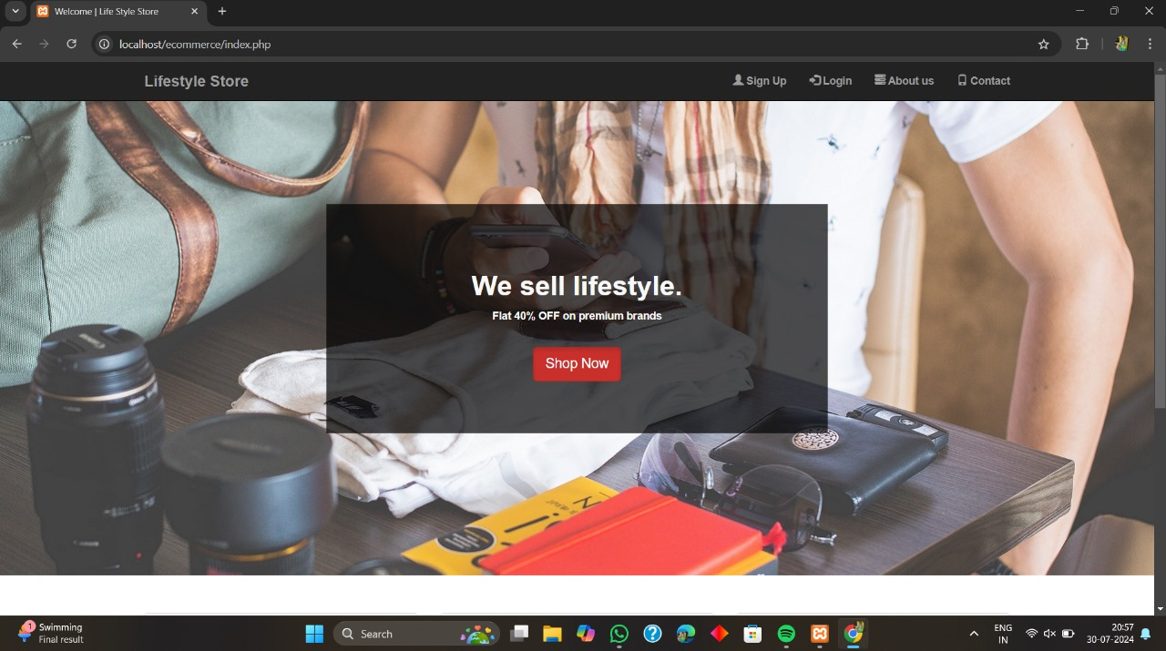

**Fig. 1: Home Page**

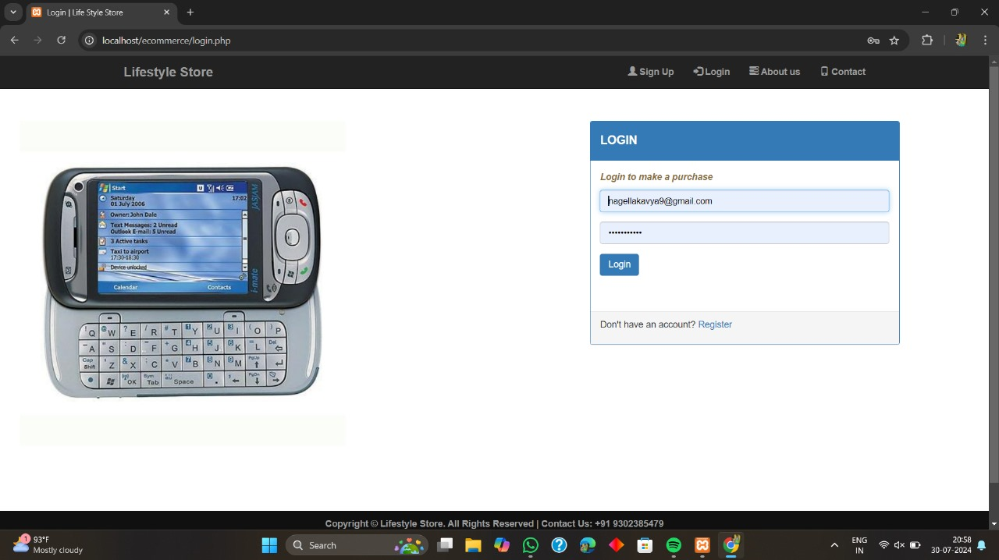

**Fig. 2: Login Page**

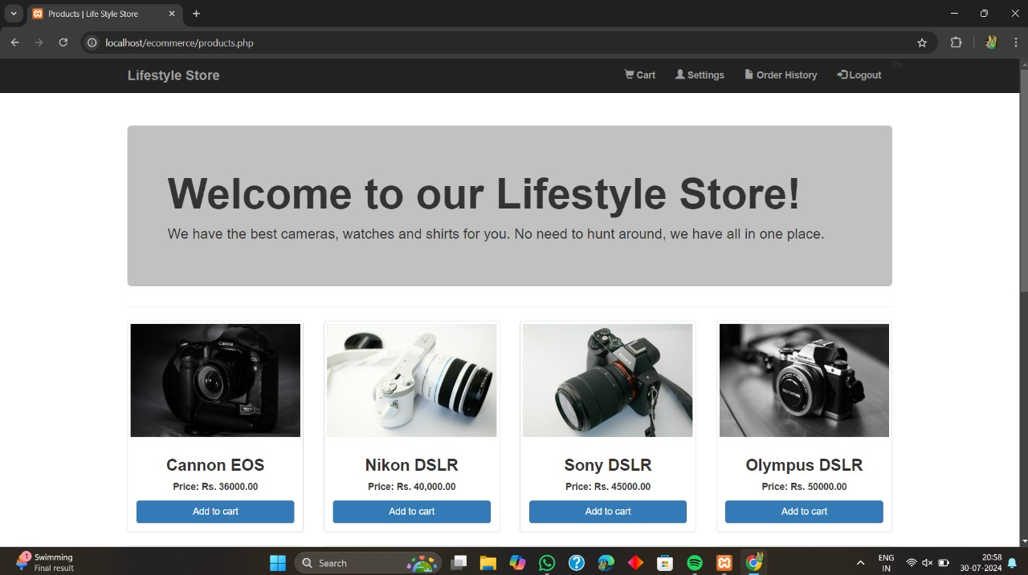

**Fig. 3: Products Page**

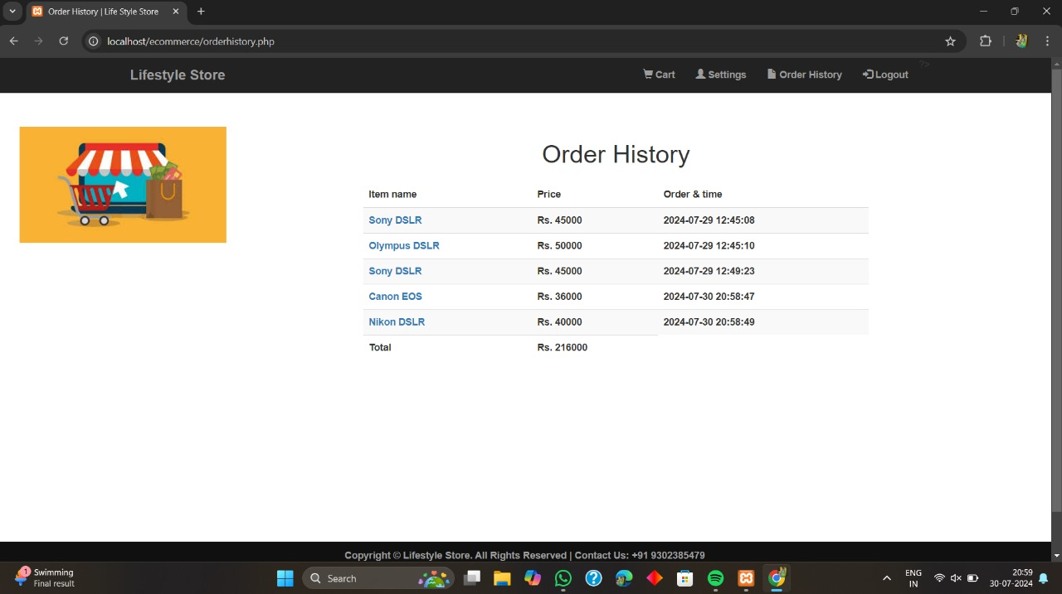

**Fig. 4: Order History Page**

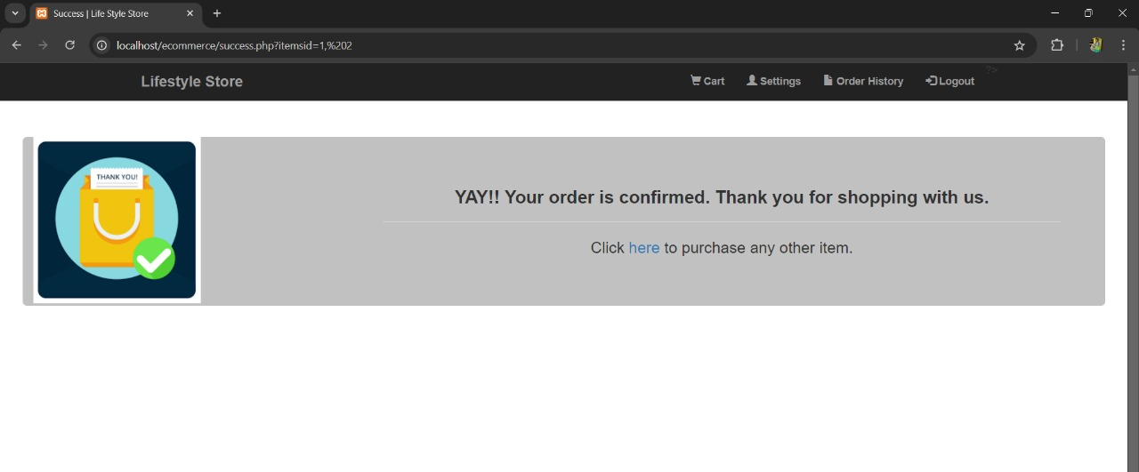 **Fig. 5: Order Confirmation Page**

**REFERENCES:**

1. Gefen, D., Karahanna, E., & Straub, D. W. (2003). *Trust and TAM in online shopping: An integrated model*. MIS Quarterly, 27(1), 51-90.
2. Kim, D. J., Ferrin, D. L., & Rao, H. R. (2008). *A trust-based consumer decision-making model in electronic commerce: The role of trust, perceived risk, and their antecedents*. Decision Support Systems, 44(2), 544-564.
3. Koufaris, M. (2002). *Applying the technology acceptance model and flow theory to online consumer behavior*. Information Systems Research, 13(2), 205-223.
4. Jarvenpaa, S. L., Tractinsky, N., & Vitale, M. (2000). *Consumer trust in an internet store*. Information Technology and Management, 1(1-2), 45-71.
5. Pavlou, P. A. (2003). *Consumer acceptance of electronic commerce: Integrating trust and risk with the technology acceptance model*. International Journal of Electronic Commerce, 7(3), 101-134.
6. Cheung, C. M., & Lee, M. K. (2005). *Consumer satisfaction with internet shopping: A research framework and propositions for future research*. Proceedings of the 7th international conference on Electronic commerce, 327-334.
7. Chen, L., Gillenson, M. L., & Sherrell, D. L. (2002). *Enticing online consumers: An extended technology acceptance perspective*. Information & Management, 39(8), 705-719.
8. Huang, Z., & Benyoucef, M. (2013). *From e-commerce to social commerce: A close look at design features*. Electronic Commerce Research and Applications, 12(4), 246-259.
9. Li, N., & Zhang, P. (2002). *Consumer online shopping attitudes and behavior: An assessment of research*. AMCIS 2002 Proceedings, 74.
10. Ha, S., & Stoel, L. (2009). *Consumer e-shopping acceptance: Antecedents in a technology acceptance model*. Journal of Business Research, 62(5), 565-571.